

Segment Target Architecture
Version Number: 1.0
Version Date: <mm/dd/yyyy>

Notes to the Author

[See the FEA Segment Architecture Methodology (FSAM) (http://fsam.gov/) for more guidance and examples.]

Segment Target Architecture Approval

The undersigned acknowledge that they have reviewed the <Segment Name> Segment Target Architecture and agree with the information presented within this document. Changes to the Segment Target Architecture will be coordinated with, and approved by, the undersigned, or their designated representatives.

[List the individuals whose signatures are desired. Examples of such individuals are Business Owner, Solution Architect, Project Manager (if identified), and any appropriate stakeholders. Add additional lines for signature as necessary.]

Signature: |  | Date:
Print Name:
Title:
Role:

Signature: |  | Date:
Print Name:
Title:
Role:

Signature: |  | Date:
Print Name:
Title:
Role:

Revision History

This table records information regarding changes made to the document over time.

Version | Date | Organization/Point of Contact | Description of Changes
1.0 | <mm/dd/yy> | <Organization Identifier / Point-of-Contact Name> | Baseline Version

Table of Contents

1. Introduction 7
2. Business Activity Model 7
3. Business Function Hierarchy 8
4. Business Process Swim Lane Diagram 9
5. Conceptual Data Model 10
6. Data Steward Matrix 11
7. Information Flow Diagram 11
8. Information Sharing Matrix 16
9. Integrated Service Component and Technology Model 18
9.1 [Service Component] -- Control Flow 18
9.2 [Service Component] -- Information Flow 19
10. Service Component Model 19
11. System Interface Diagram 22
12. Technology Model 23
13. Referenced Documents 24
14. Glossary 24
15. Acronyms 26

List of Figures

Figure 1: Target Business Activity Model 8
Figure 2: Target Business Function Hierarchy 8
Figure 3: Target Business Process Swim Lane Diagram 9
Figure 4: Target Conceptual Data Model 10
Figure 5: Target Information Flow Diagram 12
Figure 6: Service Component Control Flow 18
Figure 7: Service Component Information Flow 19
Figure 8: System Interface Diagram 22
Figure 9: Technology Model 23

List of Tables

Table 1: Target Data Steward Matrix 11
Table 2: Information Flow Description 16
Table 3: Target Information Sharing Matrix 17
Table 4: Referenced Documents 24
Table 5: Glossary 26
Table 6: List of Acronyms 26

Introduction
This document describes the Target Architecture which the future ("to be") state of the agency in terms of performance, business, data, services, and technology.

The Segment Architecture deliverables are based on the Federal Enterprise Architecture (FEA) Segment Architecture Methodology (FSAM) which consists of:

- Segment Architecture Overview. This document defines the scope, mission, and other driving factors for the segment. A governance framework may be established.

- Segment Baseline Architecture. This document describes the baseline (i.e. as-is) architecture for the segment.

- Segment Target Architecture. This document describes the target (i.e. to-be) architecture for the segment.

- Segment Architecture Recommendations. This document describes the recommendations for the segment architecture. As part of the recommendations, this document highlights the gap between the baseline and target architecture.

- Segment Architecture Migration Plan. This document describes the approach and steps to migrate from the as-is state to the to-be state, thereby achieving the target architecture.

See the Segment Architecture Overview document for background information on segment architectures and how they relate to other architectures and the IT Investment Life Cycle.

Business Activity Model
Figure 1: Target Business Activity Model illustrates optimized processes as required to achieve segment performance objectives and assists in determining high-level information and information security requirements.
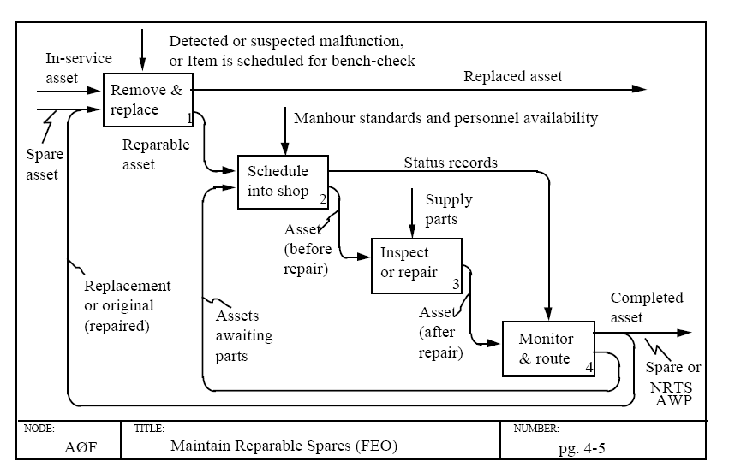
Figure 1: Target Business Activity Model

Business Function Hierarchy
Figure 2: Target Business Function Hierarchy illustrates the business functions that will be affected by potential process improvements. The Business Function Hierarchy also ensures that processes are analyzed in context with the correct business functions and that appropriate mappings to the FEA BRM are established.
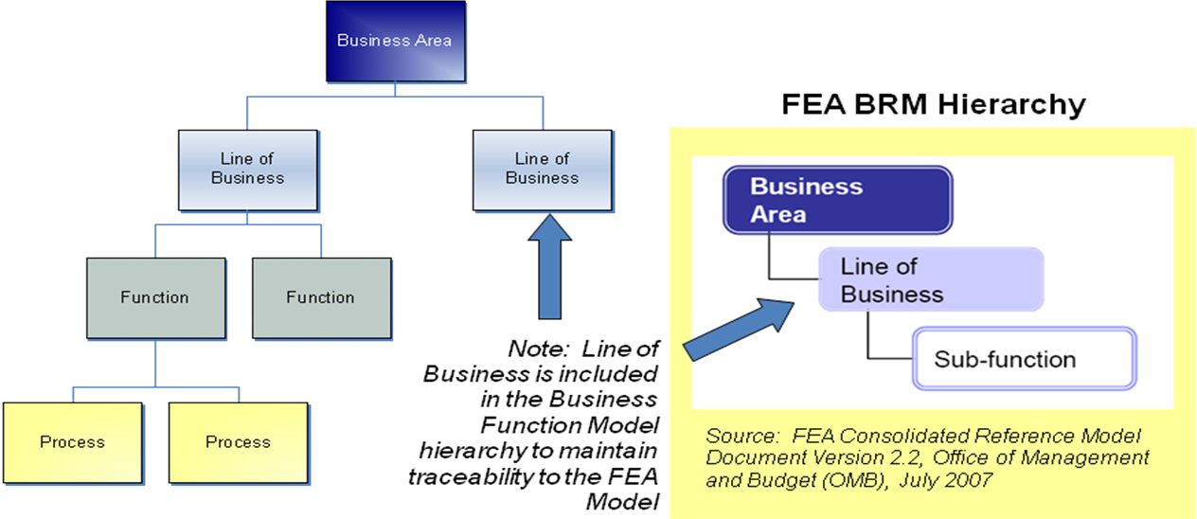
Figure 2: Target Business Function Hierarchy

Business Process Swim Lane Diagram
Figure 3: Target Business Process Swim Lane Diagram illustrates optimized processes as required to achieve segment performance objectives and assists in determining high-level information and information security requirements.
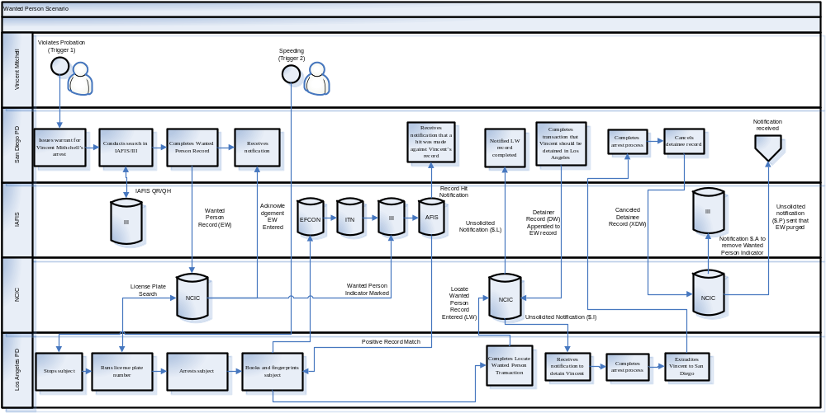
Figure 3: Target Business Process Swim Lane Diagram

Conceptual Data Model
Figure 4: Target Conceptual Data Model describes the structure and terminology for information and data in the target environment. The Conceptual Data Model includes subject areas, information classes, key entity types, and relationships.
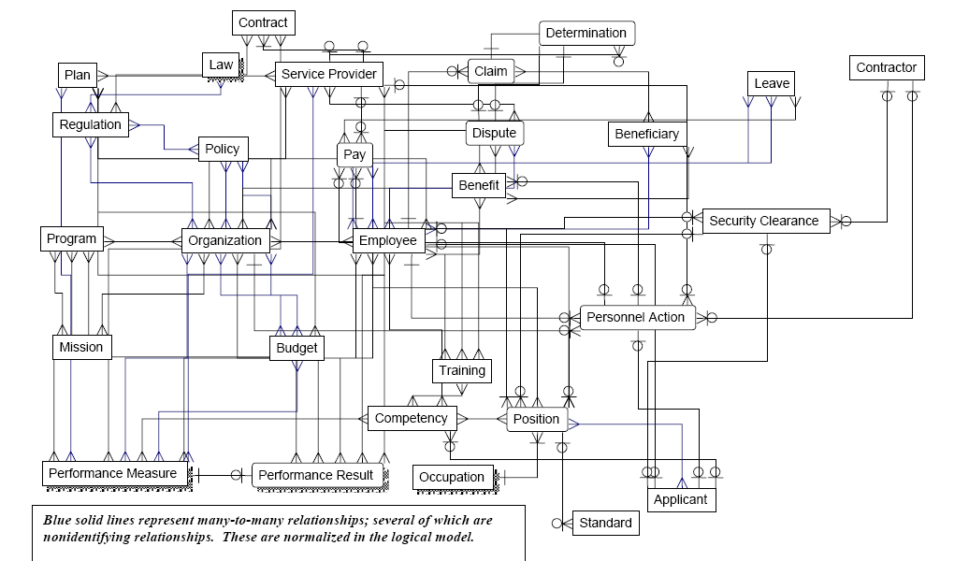
Figure 4: Target Conceptual Data Model

Data Steward Matrix
Table 1: Target Data Steward Matrix identifies the organization responsible for the creation, maintenance and quality of each information class appropriate to support business activities in the target environment.

 | Data Concept
Organization | ACTION PLAN | FIRE PROGRAM PARTNER | ISSUE | LOCATION | ORGANZIATION | PARTNER OPPORTUNITY | RECOMMENDATION | TASK REFERENCE
Org Unit 1 |  |  |  | S |  |  | S
Org Unit 2 |  | P |  | P |  |  | P
Org Unit 3 | S
Org Unit 4 | S | S | S | S | P | S |  | S
Org Unit 5 | P |  | P |  | S
Org Unit 6
Org Unit 7 | S
Org Unit 8 |  |  |  |  |  |  |  | S
Org Unit 9
Org Unit 10 |  | S |  |  | S | P
 | P = Principle Data Steward
 | S = Secondary Data Steward
Table 1: Target Data Steward Matrix

Information Flow Diagram
Figure 5: Target Information Flow Diagram depicts the flow of information across providers and consumers. The Information Flow Diagram assists in discovery of opportunities for re-use of information in the form of information-sharing services, within and between segments.

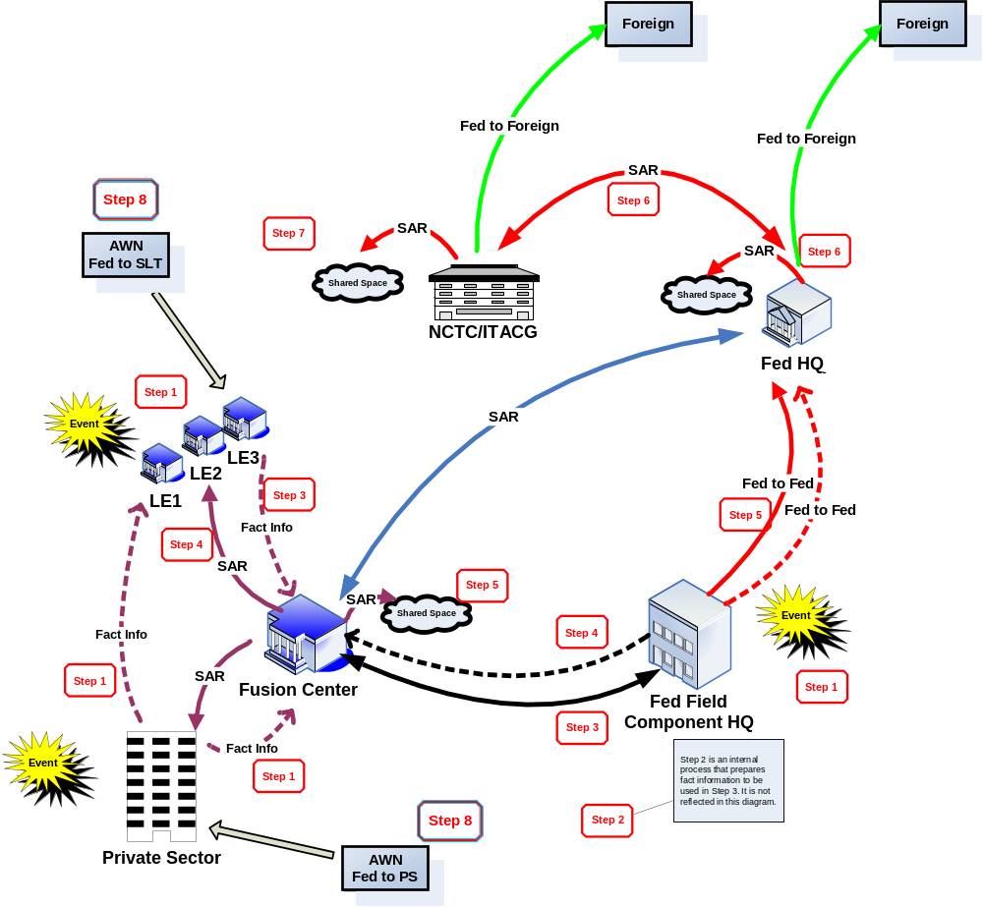
Figure 5: Target Information Flow Diagram
The diagram is accompanied by Table 2: Information Flow Description table that provides a description of steps, process description and additional notes for the business context associated with the information flows. Steps provide a logical ordering of the processes that comprise the business context. Process descriptions provide detail of the activities related to the information flows described in the diagram.

Step No. | Step Label | Process Description | Notes
1 | Observation | The process begins when a person or persons observe unusual behavior. Such activities could include, but are not limited to, surveillance, photography of facilities, site breach or physical intrusion, cyber attacks, possible testing of security or security response, indications of unusual public health sector activity, unauthorized attempts to obtain precursor chemical/agents or toxic materials, or other usual behavior or sector-specific incidents. | The observer may be a private citizen, a government official, or a law enforcement officer.
2 | Initial Response and Investigation | An official of a Federal, State, or local agency with jurisdiction responds to the reported observation. This official gathers additional facts through personal observations, interviews, and other investigative activities. In the context of priority information requirements, as provided by State and major urban area fusion centers, the officer/agent may use a number of fact based systems to continue the investigation. These fact based systems provide the officer/agent with a more complete picture of the activity being investigated. Some examples of fact based systems and the information they may provide include:  Department of Motor Vehicles provides drivers license and vehicle registration information;  National Crime Information Center provides wants and warrants information, criminal history information and access to the Terrorist Screening Center and the terrorist watch list, and Violent Gang/Terrorism Organization File (VGTOF); and,  Other Federal, State, and local systems can provide criminal checks within the immediate and surrounding jurisdictions.  When the initial investigation is complete, the official documents the event. The report becomes the initial record for the law enforcement or Federal agency’s records management system (RMS). | The event may be documented using a variety of reporting mechanisms and processes, including but not limited to, reports of investigation, event histories, field interviews (FI), citations, incident reports, and arrest reports.  The record may be hard and/or soft copy and does not yet constitute an ISE-SAR.
3 | Local/Regional Processing | The agency processes and stores the information in the RMS following agency policies and procedures. The flow will vary depending on whether the reporting organization is a State or local agency or a field element of a Federal agency.  State and local: Based on specific criteria or the nature of the activity observed, the State or local law enforcement components forward the information to the State or major urban area fusion center for further analysis.  Federal: Federal field components collecting suspicious activity would forward their reports to the appropriate resident, district, or division office. This information—still only fact information—would be reported to field intelligence groups or headquarters elements through processes that vary from agency to agency.  In addition to providing the fact information to its headquarters, the Federal field component would provide an information copy to the State or major urban area fusion center in its geographic region. This information contributes to the assessment of all suspicious activity in the State or major urban area fusion center’s area of responsibility. | The State or major urban area fusion center should have access to all suspicious activity reporting in its geographic region whether collected by SLT or Federal field components.
4 | Creation of an ISE-SAR | The determination of an ISE-SAR is a two-part process. First, at the State or major urban area fusion center or Federal agency, an analyst or law enforcement officer reviews the newly reported information against ISE-SAR criteria. Second, based on available knowledge and information, the analyst or law enforcement officer determines whether the information meeting the criteria may have a nexus to terrorism.  Once this determination is made, the information becomes an “ISE-SAR” and is formatted in accordance with ISE-FS-200 (ISE-SAR Functional Standard). The ISE-SAR would then be shared with appropriate law enforcement and homeland security personnel in the State or major urban area fusion center’s area of responsibility. | Some of this information may be intelligence, which identifies trends and other terrorist related information and is derived from Federal agencies such as NCTC, DHS, and the FBI.  For State, local, and tribal law enforcement, the ISE-SAR information, may be fact information or criminal intelligence and is handled in accordance with 28 CFR Part 23. It may be shared with State or Federal law enforcement personnel with the privacy field included.
5 | ISE-SAR Sharing and Dissemination | In a State or major urban area fusion center, the ISE-SAR is shared with the appropriate FBI field components and the DHS representative and placed in the State or major urban area fusion center’s Shared Space or otherwise made available to members of the ISE.  The FBI field component enters the ISE-SAR information into the FBI system and sends the information to FBI Headquarters.  The DHS representative enters the ISE-SAR information into the DHS system and sends the information to DHS, Office of Intelligence Analysis.
6 | Federal Headquarters (HQ) Processing | At the Federal headquarters level, ISE-SAR information is combined with information from other State or major urban area fusion centers and Federal field components and incorporated into an agency-specific national threat assessment that is shared with ISE members.  The ISE-SAR information may be provided to NCTC in the form of an agency-specific strategic threat assessment (e.g., strategic intelligence product). | When a State or local originated ISE-SAR is in the Federal system, the rules of sharing are no longer governed by 28 CFR Part 23, but rather by appropriate Federal privacy laws and guidelines.
7 | NCTC Analysis | When product(s) containing the ISE-SAR information are made available to NCTC, they are processed, collated, and analyzed with terrorism information from across the five communities—intelligence, defense, law enforcement, homeland security, and foreign affairs—and open sources.  NCTC has the primary responsibility within the Federal government for analysis of terrorism information. NCTC produces federally coordinated analytic products that are shared through NCTC Online, the NCTC secure web site.  The Interagency Threat Assessment and Coordinating Group (ITACG), housed at NCTC, facilitates the production of coordinated terrorism-related products that are focused on issues and needs of State, local, and tribal entities and when appropriate private sector entities. ITACG is the mechanism that facilitates the sharing of counterterrorism information with SLT.
8 | NCTC Alerts, Warnings, Notifications | NCTC products, informed by the ITACG as appropriate, are shared with all appropriate Federal departments and agencies and with SLT through the State or major urban area fusion centers. The sharing with SLT and private sector occurs through the Federal departments or agencies that have been assigned the responsibility and have connectivity with the State or major urban area fusion centers. Some State or major urban area fusion centers, with secure connectivity and an NCTC Online account, can access NCTC products directly. State or major urban area fusion centers will use NCTC and ITACG informed products to help develop geographic-specific risk assessments (GSRA) to facilitate regional counterterrorism efforts. The GSRA are shared with SLT organizations and the private sector as appropriate. The recipient of the GSRA may use the GSRA to develop information gathering priorities or requirements. | NCTC products form the foundation of informational needs and guide collection of additional information.  NCTC products should be responsive to informational needs of State, local, and tribal entities.
9 | Focused Collection | The information has come full circle and the process begins again, informed by an NCTC or other Federal organization’s product and the identified information needs of State, local and tribal entities and Federal field components.
Table 2: Information Flow Description

Information Sharing Matrix
The target information sharing matrix describes the type of information access and exchange services used for information classes associated with information flows that are described in Figure 5: Target Information Flow Diagram.

The information sharing service type of the DRM abstract model covers two primary aspects of data sharing for awareness, access, or exchange depending on the information sharing scenario:

- Data Exchange: Fixed, recurring transactions between parties, such as the regular exchange of environmental testing data among federal, state, local, and tribal entities. These exchanges, as described above, are implemented with data exchange services.
- Data Access: Requests for data services, such as a query of a Data Asset. These requests, as described above, are supported by Data Access Services

Table 3: Target Information Sharing Matrix is used to document target information exchanges. The purpose is to understand the types of information to be shared, who produces the information from what type of data source (structured or unstructured), who will consume the information from what type of data source (structured or unstructured), and the information sharing service type needed to support the sharing requirement. This table is intended to be expandable and extensible to include other columns or attributes that may be of interest to information flows for a particular segment.

Information  Class | Information  Provider | Information Provider Data Source (Structured or Unstructured) | Information Consumer | Information Consumer  Data Source  (Structured or Unstructured) | Information Sharing  Service Type* | High-Level Requirements
[Information Class Name] | [Name of information provider] | [Type of provider’s data source.] | [Name of information consumer] | [Type of consumer’s data source.] | [Type of Data Exchange or Data Access Service] | [Identify any associated high-level requirements related to security, privacy, data standards, etc.]

*Data Sharing Service Types are either exchange services or access services as described in FEA DRM v2.0, Chapter 5. The type of data sharing service usually depends on the structured or unstructured nature of the provider’s data source to consumer’s structured or unstructured data source.
*Types of Data Exchange Services  Extract/Transform/Load  Publication  Entity/Relationship Extraction  Document Translation | *Types of Data Access Services  Context Awareness  Structural Awareness  Transactional Services  Data Query  Content Search & Discovery  Retrieval, Subscription and Notification  Note: Access Services typically support many consumers. Generally, there is no need to identify specific consumers.
Table 3: Target Information Sharing Matrix

Integrated Service Component and Technology Model
The Integrated Service Component and Technology Model is a visual representation of how the “delivery” of the “service” is enabled by “technology components” to the “user / user types”. It is a tool for developing the Technology Model and has two aspects: Control Flow and Information Flow. A service component is NOT independent and self-contained. It may invoke/use other service components for fulfillment. Information flowing between service components and/or a service component and user is defined in the Data Reference Model as an Information Exchange Package. There is a many-to-many relationship between service components. It means that the one Information Exchange Package (or a subset of it) can be exchanged between one or more pairs of Service Components.

[Service Component] -- Control Flow

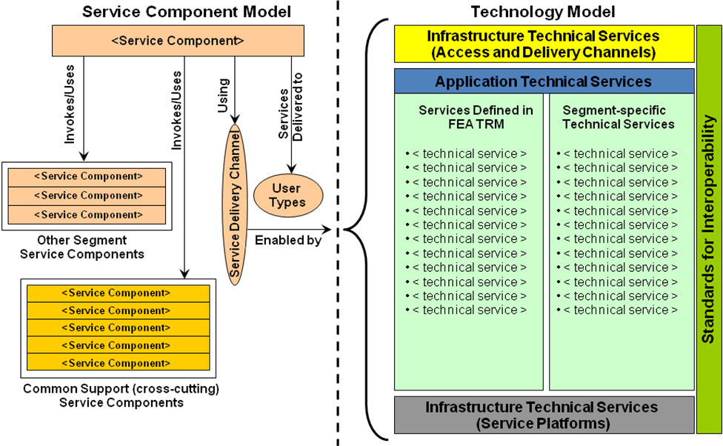
Figure 6: Service Component Control Flow

[Service Component] -- Information Flow
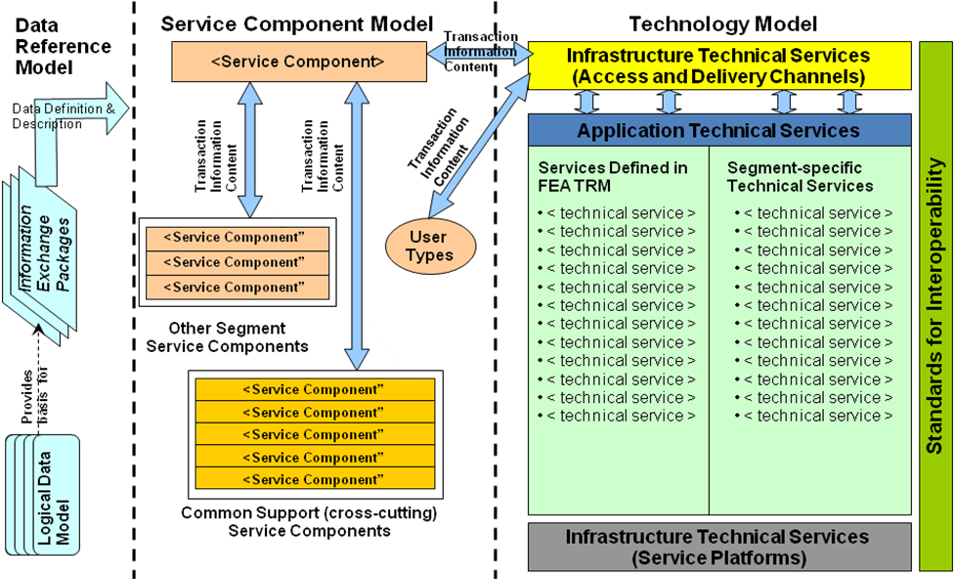
Figure 7: Service Component Information Flow

Service Component Model
The Service Component Model provides a framework for identifying and defining the business capability that must be in place to support BRM business processes. The Service Delivery Model takes this analysis further and recommends how each capability may be made available to the consumers of the capability. The Service Delivery Model identifies and defines the various consumers of services, or “user types”. It maps those users to service components, and for each instance proposes the "delivery channel" to be used to deliver the service in an effective and efficient manner.

[The service delivery model identifies and defines the various consumers of services, or “user types”. It maps those users to service components, and for each instance proposes the "delivery channel" to be used to deliver the service in an effective and efficient manner.

User Types: User types are generic customers – constituents that might take advantage of or consume a service. User types are role-based in nature; an individual may perform different roles depending on the activity being performed.

Service Delivery Channels: Service delivery channels indicate the manner in which each service component would be accessed by the users who have access to it. Typically, delivery channels are organized into a tiered structure. The users of each service component gain access at a particular level and may be escalated to successively higher levels as necessary.]

0 | Tier 0 – Direct Access. The Direct Access tier enables the user to perform an action related to the task or activity without any direct involvement or guidance from another person. This environment provides the capability for managers and employees to directly enter and receive data. It also provides a means for communicating critical information, posting FAQs, and announcing policies and procedures.
1 | Tier 1 – Call Center. The Call Center tier enables the user to speak to a Human Resource generalist who utilizes scripts and knowledge base to respond to a wide variety of questions and issues. If necessary, a call center human resources generalist may transfer a call to a subject matter expert at tier 2.
2 | Tier 2 – Subject Matter Expert. The Subject Matter Expert tier interprets policy to respond to escalated issues and questions. The subject matter expert usually has a specialized experience or knowledge in a specific topic that the service component is related to (e.g., benefits processing) and is typically empowered to make routine or low-risk decisions. A subject matter expert may transfer a question or issue it to a decision maker at tier 3.
3 | Tier 3 – Decision Maker. The Decision Maker tier responds to complex issues, questions and critical incidents. The decision maker interprets policy and has decision-making authority around complex issues, questions and critical incidents. They also maintain operational oversight and focus on employee satisfaction.

Service Domain | Service Type | Service Component | User Type | User Type | User Type | User Type | User Type
Service
Domain
Service  Domain | Service Type | Service Component
Service  Domain | Service Type | Service Component
Service  Domain | Service Type | Service Component
Service  Domain | Service Type | Service Component
Service  Domain | Service Type | Service Component
Service  Domain | Service Type | Service Component
Service  Domain | Service Type | Service Component
Service  Domain | Service Type | Service Component
Service  Domain | Service Type | Service Component
Service  Domain | Service Type | Service Component
Service  Domain | Service Type | Service Component
Service  Domain | Service Type | Service Component
Service  Domain | Service Type | Service Component
Customer Services
Customer Services | Service Type | Service Component
Customer Services | Service Type | Service Component
Customer Services | Service Type | Service Component
Customer Services | Service Type | Service Component
Customer Services | Service Type | Service Component
Customer Services | Service Type | Service Component
Customer Services | Service Type | Service Component
Customer Services | Service Type | Service Component
Customer Services | Service Type | Service Component
Customer Services | Service Type | Service Component
Customer Services | Service Type | Service Component
Customer Services | Service Type | Service Component
Customer Services | Service Type | Service Component
 | key: | direct access | 0
 |  | call center | 1
 |  | subject matter expert | 2
 |  | decision maker | 3

System Interface Diagram
Figure 8: System Interface Diagram depicts the target systems and the relationships between them.
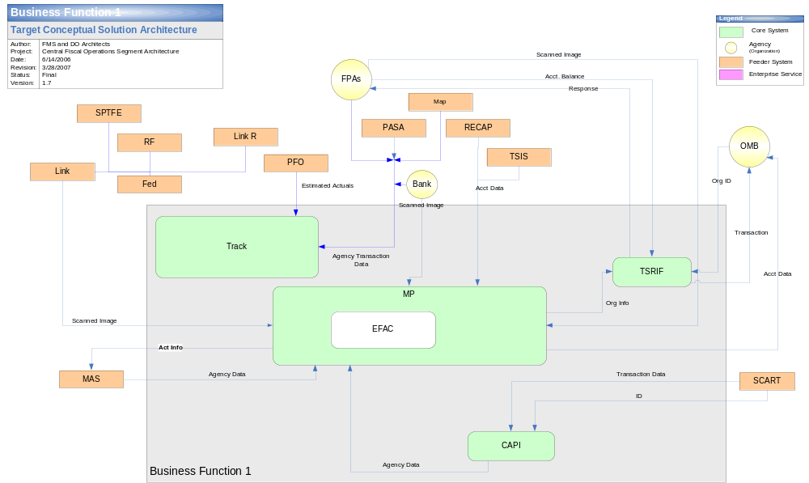
Figure 8: System Interface Diagram

Technology Model
Figure 9: Technology Model defines the target technology architecture for the segment. The TM components are specified for each corresponding service component consistent with the technical components identified within the organization’s enterprise architecture technical reference model (TRM). The TM may also include the identification of infrastructure access, delivery, and service platforms along with applicable interoperability standards. Segment specific-technical services may also be defined for technical components not included in the TRM.
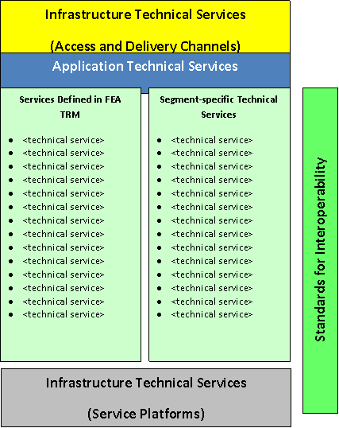
Figure 9: Technology Model

Referenced Documents
Table 4: Referenced Documents lists all documents used to arrive at and/or referenced within this document (e.g., related and/or companion documents, prerequisite documents, relevant technical documentation, etc.).

Document Name | Issuance Date
 | <Month Day, Year>
Table 4: Referenced Documents

Glossary
This section defines the terms used in the document that may be unfamiliar to readers of the document.
Term Name | Definition | Source
Baseline Architecture | Describes the current ("as is") state of the agency in terms of performance, business, data, services, and technology. | FEA
Business Architecture | A functional perspective of the overall agency EA, providing information about the agency's baseline and target architectures. Examples of elements are:  - Agency business processes, aligned to business sub-functions within the FEA BRM  - Internal and external participants (roles) within these business processes  - Linkage between agency business processes and agency-specific performance measurement indicators  - Linkage between business processes to agency service components  - Agency programs, linked to business processes  - Offices and facilities. | FEA
Business Services | Defined by the agency business model, business services include the foundational mechanisms and back-office services used to achieve the purpose of the agency, e.g., inspections and auditing, direct loans, program monitoring, and financial management. | FEA
Conceptual Solution Architecture | The conceptual solution architecture defines the segment systems and services (e.g., business and information exchange) including the supporting technical and service components. | FEA
Core Mission Areas | Unique service areas that define the mission or purpose of the agency. Core mission areas are defined by the agency business model (e.g., tactical defense, air transportation, energy supply, pollution prevention and control, and emergency response). | FEA
Data Model | A data model in software engineering is an abstract model that describes how data is represented and accessed. Data models formally define data objects and relationships among data objects for a domain of interest. | FEA
Enterprise Architecture | A management practice for aligning resources to improve business performance and help agencies better execute their core missions. An EA describes the current and future state of the agency and lays out a plan for transitioning from the current state to the desired future state. | FEA
Performance Architecture | A perspective of the overall agency EA that provides information about the agency's baseline and target architectures. Examples of elements are:  - Agency strategic goals and objectives (as per the agency's Strategic Plan and IRM Plan) and linkage between performance indicators and business processes  - Agency-specific performance measurement indicators aligned to the generic measurement indicators described in the FEA PRM  - Linkage between the agency's strategic goals and investments. | FEA
Segment | Individual elements of the enterprise describing core mission areas and common or shared business services and enterprise services. Segments are defined by the enterprise architecture. | FEA
Segment Architecture | Detailed results-oriented architecture (baseline and target) and a transition strategy for a portion or segment of the enterprise. | FEA
Service | Discrete unit of functionality that can be requested (provided a set of preconditions is met), performs one or more operations (typically applying business rules and accessing a database), and returns a set of results to the requester. Completion of a service always leaves business and data integrity intact. | FEA
Solution Architecture | An architecture for an individual IT system that is part of a segment. A solution architecture is reconciled to the segment architecture above it. | FEA
Stakeholder | A person, group, organization, or system who affects or can be affected by an organization's actions. | FEA
Target Architecture | Describes the future ("to be") state of the agency in terms of performance, business, data, services, and technology. | FEA
Vision Statement | Summary description of the target business and information management environment to fulfill requirements, address change drivers, and achieve performance improvements. | FEA
Table 5: Glossary

Acronyms
This section provides a list of acronyms and associated literal translations used within the document.
Acronym | Literal Translation
EA | Enterprise Architecture
FEA | Federal Enterprise Architecture
Table 6: List of Acronyms

Suspicious activity reporting (SAR) is an official documentation of observed behavior that may be indicative of intelligence gathering or pre-operational planning related to terrorism, criminal, or other illicit intention. ISE-SARs are a subset of all SARs that have been determined by an appropriate authority to have a potential nexus to terrorism.
If a suspicious activity has a direct connection to terrorist activity the flow moves along an operational path. Depending upon urgency, the information could move immediately into law enforcement operations and lead to action against the identified terrorist activity. In this case, the suspicious activity would travel from the initial law enforcement contact directly to the law enforcement agency with enforcement responsibility.
NCTC product include: Alerts, warnings, and notifications—identifying time sensitive or strategic threats; Situational awareness reports; and Strategic and foundational assessments of terrorist risks and threats to the United States and related intelligence information.

